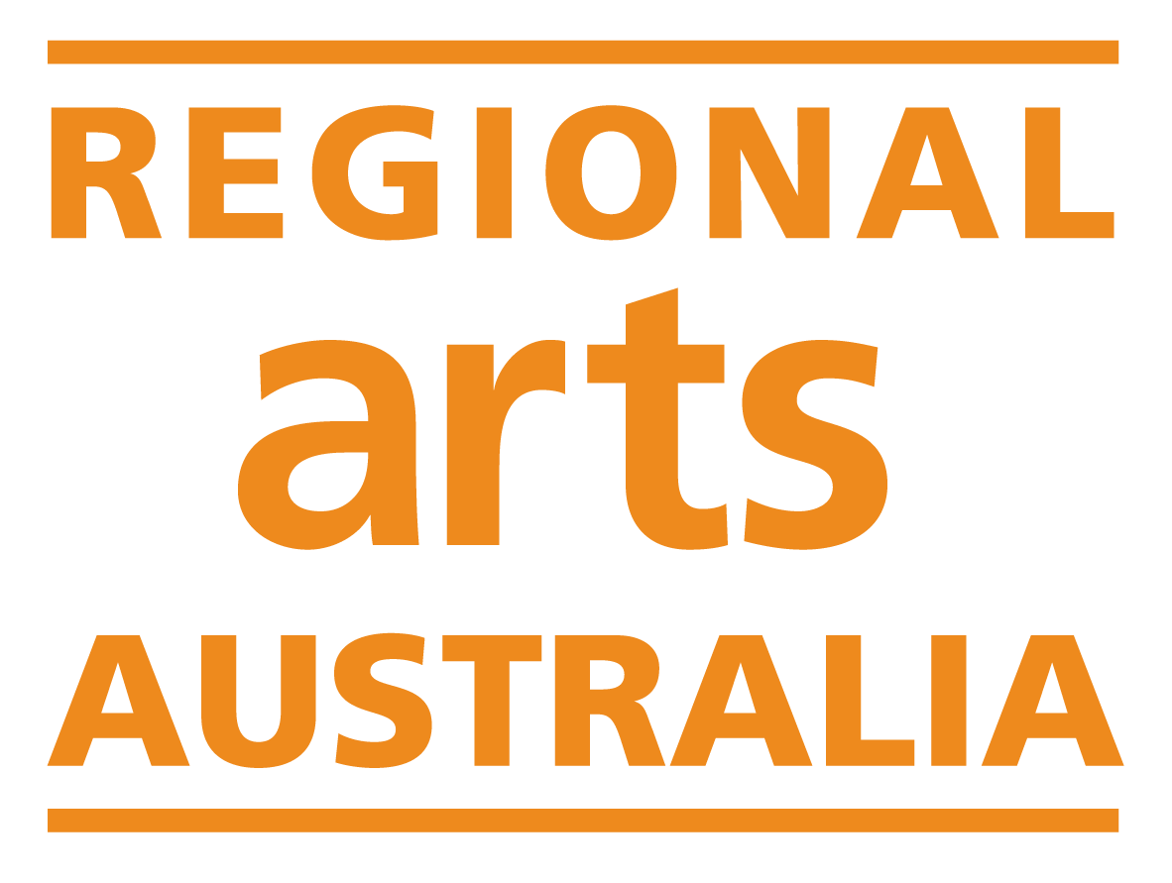

Regional Arts Fund

Quick Response Grant

Application Form

Quick Response Grants are provided through the Australian Government's Regional Arts Fund, devolved through Regional Arts Australia and administered in each state by Regional Program Administrators.
Quick Response Grants support small, time-sensitive opportunities for artists and arts workers in regional and remote Australia. They are for opportunities that arise unexpectedly, can’t be planned ahead of time, and can’t wait for a larger funding round.
Funding for up to $3,000 for individuals, or $5,000 for organisations is available through this grant program. There is no minimum amount you can apply for.

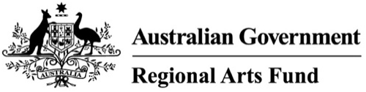
The Regional Arts Fund is an Australian Government program that supports sustainable cultural development in regional and remote communities in Australia.

Preparing to write your application
For the best chance at success, we strongly encourage you to read the program guidelines and contact the Regional Program Administrator in your State or Territory to discuss your application. They are here to help and can help you to understand how your project fits within the guidelines of the fund.
Download the Regional Arts Fund Program Guidelines.
Find the contact details for your Regional Program Administrator.

Have you read through the Regional Arts Fund Guidelines?
Yes
No

Have you discussed your application with the Regional Program Administrator in your State or Territory?
Yes
No

If yes, which staﬀ member did you discuss your application with?

Contact Details
Please provide the contact details for the primary applicant. This should be the person or organisation listed on the ABN you provide.
If you are applying on behalf of an organisation, please provide the organisation name and contact details below. You will be asked to provide a contact person within the organisation later in the form.

Applicant Name:

Email:

Phone Number:

Website:

Organisation Primary Contact
If you are not applying on behalf of an organisation, please skip to the next question.
Name:
Email:
Phone Number:
Website:

Eligibility
The Regional Arts Fund provides designated funding for organisations and individuals that are based in regional areas. Organisations or individuals based in metropolitan locations are not eligible to apply for the Regional Arts Fund.
To determine eligible locations, the fund uses the Modified Monash Model. You enter your primary address into the Regional Arts Fund Eligibility Map to find out the MM classification. This address should match the address on your ABN.

Have you received a Regional Arts Fund Quick Response grant in this financial year?
Yes: You are not eligible to apply for this funding.
No

Do you have any outstanding acquittals for the Regional Arts Fund, or other Government grants?
Yes: You are not eligible to apply for this funding.
No

What is the MM classification of your primary address?
MMM 1: You are not eligible to apply for this funding.
MMM 2
MMM 3
MMM 4
MMM 5
MMM 6
MMM 7

Will your activity start within 2-12 weeks from the closing date of this round?
Yes
No: You are not eligible to apply for this funding.

Does this activity have an immediate need for funding?
Yes
No: You are not eligible to apply for this funding.

When did you find out about this opportunity?
(150 words max.)

Tell us why this opportunity cannot happen at any other time:
(150 words max.)

What type of applicant are you?
Individual
Individual under 18 (requires Auspice)
Incorporated Association
Unincorporated Group (requires Auspice)
Local Government
Company Limited by Guarantee
School (MM7 locations only)
Other: You are not eligible to apply for this funding.

If you selected Individual under 18 or Unincorporated Group, please answer the next question. If not, please skip to Applicant Details.

Auspice Information
Individuals under 18: You will need your application to be auspiced by an individual who is over 18 and has an active ABN.
The individual auspicing your application should be aware that they will need to enter into a legally binding grant agreement with the Regional Program Administrator.
The individual auspicing your application will be responsible for meeting the obligations set out in the agreement as well as managing, reporting on and acquitting the funding.

Unincorporated Groups: You will need your application to be auspiced by an organisation that meets the following criteria:
- an Australian incorporated organisation or local government organisation
- if required by the Australian Tax Office, be registered for the purposes of GST
- not have any outstanding reports, acquittals or serious breaches relating to any Australian Government funding or funding from a state or territory Regional Program Administrator. A serious breach is one that has resulted in, or warrants, the termination of a grant agreement.
All activities undertaken must have the support and approval of the auspice body.
You and your auspice body should be aware that the auspice body will need to enter into a legally binding grant agreement with the Regional Program Administrator. The auspice body will be responsible for meeting the obligations set out in the agreement as well as managing, reporting on and acquitting the funding.

Please enter the contact details for your Auspice below.

Name:

Email:

Phone Number:

ABN:

Primary Address:

Postal Address:

Applicant Details

Applicant Location
Please provide the street address of your primary location. This should match the address registered on your ABN.

Address:

Suburb/Town:

State/Territory:

Postcode:

Applicant ABN

ABN:

Does your registered 'Main business location' match your primary address provided?
Yes
No: Please contact the Australian Business Register to update your details. Funding can only be paid to applicants whose primary address matches their ABN ‘Main business location’. You can submit this form and then update your ABN registered address. We will still process your application.

Grant Activity

Activity Summary
Please note, the Project Title and Project Summary entered below must be suitable for publication. These details will be used to promote your project, if successful. We recommend that the Project Summary is written in the third person and does not contain dots points or lists.

Project Title:

Project Summary: (150 words max)

Start Date:

End Date:

Activity Type:
Arts project
Professional development for artists and arts workers
Community capacity building project

What is the main artform of your activity?
Circus
Community Arts
Crafts
Cross Artform
Cultural Heritage
Dance/Physical Theatre
Digital Arts
Film
Literature
Music
Puppetry
Theatre
Visual Arts

Activity Details
The questions below help us to understand how your project aligns with the Regional Arts Fund objectives.

What do you want to do and why? (Opportunity, Impact & Reach)
(300 words max.)

Who is involved in your project and how will they benefit from it? (Support & Partnerships)
(300 words max.)

How will you make it happen? (Quality & Viability)
(300 words max.)

Project Location

Where will your activity take place?

People

How many people will be employed by this activity?

How many people will receive professional development opportunities through this activity?

Who is the primary beneficiary of your project?
Aboriginal/Torres Strait Islander people
Artists and arts workers
Children (0-14 years)
General community
Older people
People from culturally and linguistically diverse backgrounds
People with a disability
Youth (12-25 years)

Is this activity being led by the primary beneficiary listed above?
Yes - the Applicant or Project Lead(s) identifies with the primary beneficiary listed above.
No - the Applicant or Project Lead(s) do not identify with the primary beneficiary listed above.
If you answered yes above, please skip to the next question.
When working with communities or groups that are not your own, it's helpful to show assessors that the primary beneficiary community or group wants this project to happen. In order to increase the competitiveness of your application, tell us about any consultation you have done with the primary beneficiary and include any letters of support in your support material.

What is your relationship to the primary beneficiary?

Budget
Please complete the Regional Arts Fund Quick Response Grant Budget template and submit it alongside this document.
How have you calculated any wages or artist fees?

Is there any other information you would like to provide about your budget that might help explain it to the assessors?

Support Material

CV

I confirm I have attached the applicant CV, or, if the applicant is an organisation, the strategic plan or CV of the project lead.

Support Material
Please provide your support material as an attachment to this document of no more than 10 pages. Please note that letters of participant and partner confirmation, and budget supporting material do not count toward the 10-page total.
Submitting support material will be of benefit to your application. The assessors will review this support material to help them gain a better sense of your project.
Examples of support material include:
- Artistic support material: Image, text, video or audio examples of the applicant's artistic or cultural work.
- Artist or participant information: Brief bios or CV's for key artists, personnel or collaborators.
- Letters of support: Official letters from organisations or individuals expressing their financial or in-kind support for the activity, or explaining how the activity will benefit the applicant, artists, arts professionals, participants, or the broader community.
- Letters of invitation/acceptance: Official acceptance or invitation letters or emails to the applicant from an organisation or individual running an educational program, conference, residency or similar.

Please identify which types of support material you have included:
Artistic support material (images or text)
Artistic support material (video or audio)
Artist/participant information
Letters of support
Letter of invitation/acceptance
Other:

Links
You may choose to provide direct links to video or audio support material.
A maximum of three (3) direct links of audio or video (no greater than three minutes in length) can be uploaded.
Description | Link

Protocols

Aboriginal and Torres Strait Islander People and Cultural Materials
Applicants funded under the Regional Arts Fund who are working with Indigenous Australian artists, need to comply with Creative Australia Protocols for using First Nations Cultural and Intellectual Property in the Arts.
Your project involves Aboriginal and/or Torres Strait Islander people or cultural content If any project staff, artists, or participants are Aboriginal or Torres Strait Islander, or any content engages with Aboriginal or Torres Strait Islander histories or communities.

Does your project involve Aboriginal and/or Torres Strait Islander people or cultural content?
Yes
No: please skip to the next section.

If yes, please confirm that you have read and will comply with Creative Australia's Protocols for using First Nations Cultural and Intellectual Property in the Arts:
I confirm

Explain how you will comply with the Protocols for using First Nations Cultural and Intellectual Property in the Arts:

Working with Children

Does your project (at any stage) involve working with children?
Yes
No: please skip to the next section.

Please list the names of all personnel who will be working with children at any time during this project. For each person, identify the status of their Working with Children Check (WWCC) and provide details if relevant.
If your application is successful, you will be required to provide current WWCC details for all personnel listed below, prior to the project commencing.
Please add new lines to the table as required.
Name | Does this person have a current WWCC? | WWCC Number | WWCC Expiry Date
Yes
No
Yes
No

I understand that I will be required to provide evidence of current Working With Children Checks for all personnel listed above, prior to funding being awarded.

Has anyone involved in your project undertaken training in the National Child Safety Principles?
Yes
No
If yes, please provide the name of the person involved in your project who has undertaken training in the National Child Safety Principles. Please also provide evidence that the training has been undertaken.

Name:
If no, please read the below.
If successful, at least one person involved in this project be required to undertake training in the National Child Safety Principles, prior to the funding agreement being signed.
The Australian Human Rights Commission has developed a suite of e-learning modules to help organisations increase their knowledge and understanding of the National Principles and identify steps they need to take as they work towards implementing National Principles for Child Safe Organisations.
There are 11 e-learning modules. They include an introductory module which gives an overview of the development and content of the National Principles, and separate modules on each of the ten National Principles. Each module will take participants around 20 minutes.
The modules are intended to help people working or volunteering in all organisations that engage with children and young people – including organisations of various sizes, across Australia, in all sectors. They provide introductory content as well as links to more detailed resources and practical tools.
These modules are free, and we recommend that you begin completing them now to allow for a quick turnaround should your application be successful.
Access the E-Learning Modules: https://childsafe.humanrights.gov.au/learning-hub/e-learning-modules

I understand that I will be required to provide evidence of completed training in the National Child Safety Principles, prior to funding being awarded.

Please provide the name of the person who will undertake NCSP training:

Vulnerable Persons
Vulnerable Person means an individual aged 18 years and above who is or may be unable to take care of themselves, or is unable to protect themselves against harm or exploitation for any reason, including age, physical or mental illness, trauma or disability, pregnancy, the influence, or past or existing use, of alcohol, drugs or substances or any other reason.

Does your project (at any stage) involve working with vulnerable persons?
Yes
No: please skip to the next section.

If successful, you will be required to provide a Category 37 Australian Federal Police (AFP) check for each person that will be working with vulnerable people. The AFP checks must be no more than 12 months old.
You can apply for an AFP check online or by mail: https://www.afp.gov.au/what-we-do/national-police-checks
These checks must be received before the project can commence.
The cost of the AFP checks can be covered by this grant, please make sure to include it in your budget.
Please list the names of all personnel who will be working with vulnerable persons at any time during this project:

I understand that I will be required to provide AFP checks for each person listed above, prior to funding being awarded.

Data Collection
The following questions help us to identify who is accessing our programs, and what kind of individuals/communities are receiving funding. Your answer will not affect the assessment of your application, but will help us with advocacy and to shape future programs.

Applicant Demographics
If you are applying as an organisation, please skip to the next question.

Do you identify with any of the following groups?
Aboriginal or Torres Strait Islander
Culturally and Linguistically Diverse
A person with disability
LGBTQIA
Youth (25 years and under)
None of the above
Would rather not say
Other:

Organisation Data
If you are applying as an individual, please skip to the next question.

Is your organisation an Indigenous or Non-Indigenous organisation?
Indigenous: Any organisation where 50 per cent or more of its Board Directors are Aboriginal or Torres Strait Islander people.
Non-Indigenous

What size is your organisation?
Micro (annual turnover under $100,000)
Small (annual turnover $100,000 - $349,999)
Medium (annual turnover $350,000 - $2,999,999)
Large (annual turnover $3,000,000 and above)

Regional Arts Fund History

What is your history with the Regional Arts Fund?
I have received a RAF grant
I have applied, but never been successful
I have never applied

Privacy Statement
The information requested in this application form is to be used for the purposes of determining whether or not an individual or organisation is eligible for funding. Regional Arts Australia and its network of Regional Program Administrators also uses the information supplied to distribute mail of interest, such as: newsletters, events, and funding opportunities. Applicants that do not wish to be on this mailing list should notify their Regional Program Administrator in their state or territory.
Regional Arts Australia values your privacy. For details on how we collect, store and use information, you may review our Privacy Policy here.
The Australian Government stipulates that application details and applicant contact information may be provided to the Australian Government (including the Minister and the Department), Members of Parliament, Regional Arts Australia, and other Regional Program Administrators (in your state or territory). This will include the applicant’s name, funded project description, funded amount, state/territory, town, and federal electorate. This information may be published online and used for promotion and reporting purposes. Regional Arts Australia may also use this information to conduct research so that we may better understand community needs and can improve service delivery.

I agree to the above

Conflicts of Interest
To make sure that your application is assessed fairly, we need to know if any conflicts of interest might arise for you and/or any of your personnel.

Do you or any of your personnel have a professional, commercial or personal relationship with any staff employed by the Regional Program Administrator, Regional Arts Australia, or the Office for the Arts?
Yes
No

If yes, please provide the name of the person, their role, and a brief description of your connection:

Declaration

I certify that:
I have read the Regional Arts Fund guidelines for the program that I am applying to.
All details supplied in this application and in any attached documents are true and correct to the best of my knowledge.
I understand the application will not be accepted if it is submitted late or subject to outstanding acquittals.
If applying as an organisation or group, that the application has been submitted with the full knowledge and agreement of my organisation/group board.
I agree that I will contact the Regional Program Administrator in my State or Territory immediately if any information provided in this application changes or is incorrect.
I understand that all assessment decisions are final.

Name of person making declaration:

Date of declaration:

